Reading Newspaper Articles
Second Assignment

What We’re Not Looking After: Our Eyes



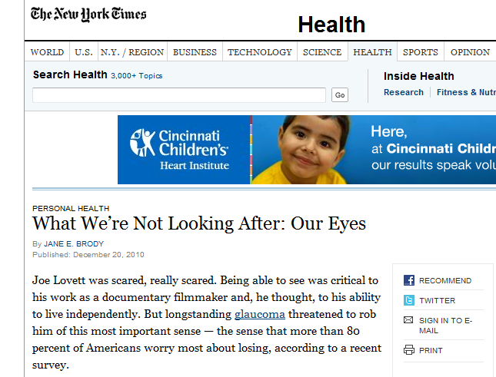

Before reading :

- What does this article talk about?

- Do you take good care of your eyes ? how?

Now go to the next Page below.

Personal Health

What We’re Not Looking After: Our Eyes

By JANE E. BRODY

Published: December 20, 2010
Joe Lovett was scared, really scared. Being able to see was critical to his work as a documentary filmmaker and, he thought, to his ability to live independently. But longstanding glaucoma threatened to rob him of this most important sense — the sense that more than 80 percent of Americans worry most about losing, according to a recent survey.
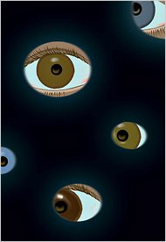
Partly to assuage his fears, partly to learn how to cope if he becomes blind, and partly to alert Americans to the importance of regular eye care, Mr. Lovett, 65, decided to do what he does best. He produced a documentary called “Going Blind,” with the telling subtitle “Coming Out of the Dark About Vision Loss.”
In addition to Mr. Lovett, the film features six people whose vision was destroyed or severely impaired by disease or injury:
- Jessica Jones, an artist who lost her sight to diabetic retinopathy at age 32, but now teaches art to blind and disabled children.
- Emmet Teran, a schoolboy whose vision is limited by albinism, a condition he inherited from his father, and who uses comedy to help him cope with bullies.
- Patricia Williams, a fiercely independent woman legally blind because of glaucoma and a traumatic injury, who continues to work as a program support assistant for the Veterans Administration.
- Steve Baskis, a soldier blinded at age 22 by a roadside bomb in Iraq, who now lives independently and offers encouragement to others injured at war.
Sadly, the nationwide survey (conducted Sept. 8 through 12 by Harris Interactive) showed that only a small minority of those most at risk get the yearly eye exams that could detect a vision problem and prevent, delay or even reverse its progression. Fully 86 percent of those who already have an eye disease do not get routine exams, the telephone survey of 1,004 adults revealed.
After Reading the Article Taken from New York Times, answer the following questions :

- What is the disease that threaten Joe Lovett?

- “Coming Out of the Dark About Vision Loss.” Is the title of what?

- Who of those people mentioned above you sympathize with more than others?

- If those people did their yearly eye exam would they decrease the effect of the disease they have?

- Do you take your eye exam regularly?

The End..

